**Papers written by**

**Australian Maths Software**

**REVISION 2**

**2016**

**SEMESTER 2**

**MATHEMATICS**

**APPLICATIONS**

**Units 1 & 2**

**SOLUTIONS**

**SECTION 1 – Calculator-free**

**Question 1 (4 marks)**

(a) 4 + 12 + 3 = 19 cm ✓

✓

(b) 

✓



The diagonal route is 6 cm shorter. ✓

**Question 2 (4 marks)**

(a) $10x4 + $30x8x4 = $40 + $960 = $1000

✓ ✓

(b) Shop 

Shop price is $16.20 ✓

Online is $16

Cheaper to buy online by 20 cents. ✓

**Question 3 (6 marks)**

(a)  ✓

(b)  ✓✓✓ -1/error

(c)  ✓✓ -1/error

**Question 4 (20 marks)**

(a) (i)

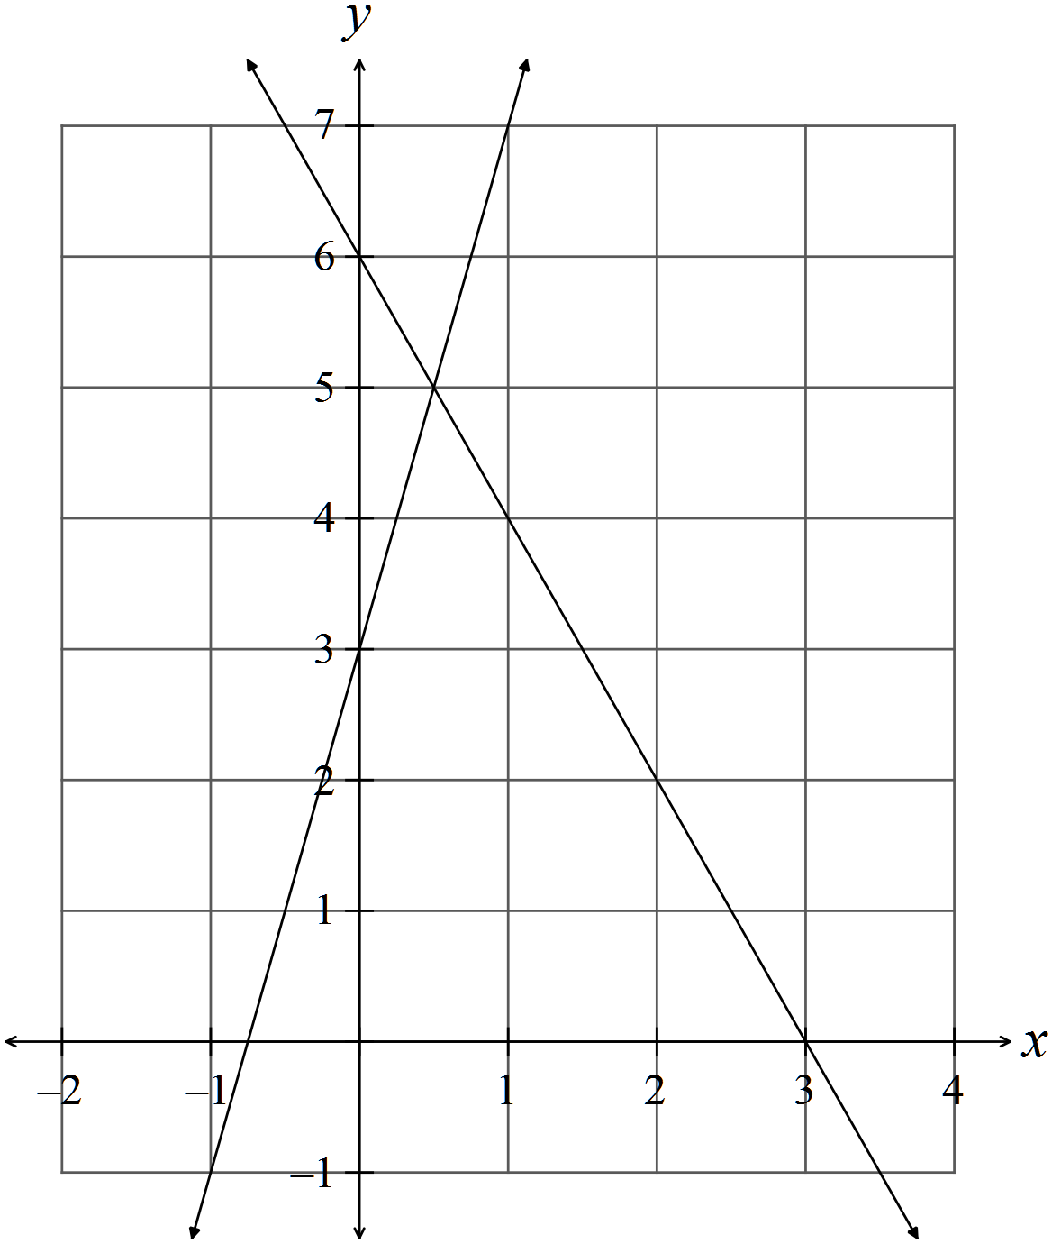✓✓

(ii)  ✓✓

(iii)  ✓

 ✓

This confirms the point of intersection.

(b) 

✓



✓

✓

(c) 

✓



✓

✓

✓

(d)

✓

 OR 

✓

✓

✓

✓

**Question 5 (12 marks)**

(a) (i)

✓

✓

✓

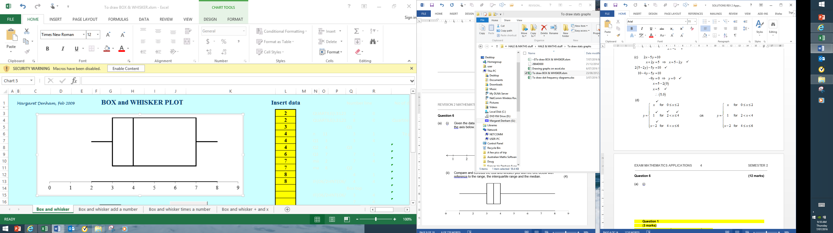

✓

(ii)

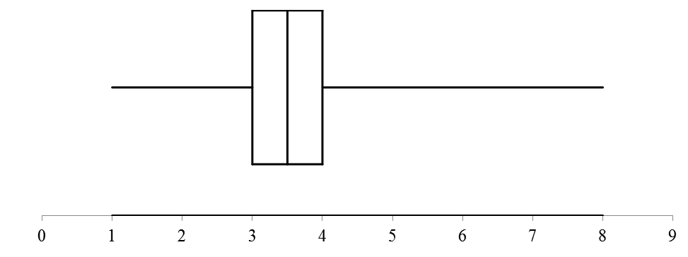

Box plot 1 has a range of 8 - 2 = 6 and IQR = 7- 3 = 4. ✓

Box plot 2 has a range of 8 - 1 = 7 but a much more highly clustered middle 50% with

the IQR = 4- 3 = 1. ✓

The medians are similar 4 and 3.5. ✓

Data 2 may well have an outlier at 8. The ranges are similar.

Data 1 is skewed as 25% of the scores are between 3 and 4 and the next 25% of scores

are between 4 and 7. ✓

(iii) On a box and whisker plot, the individual scores are not seen so the standard

deviation cannot be determined. ✓

(b)

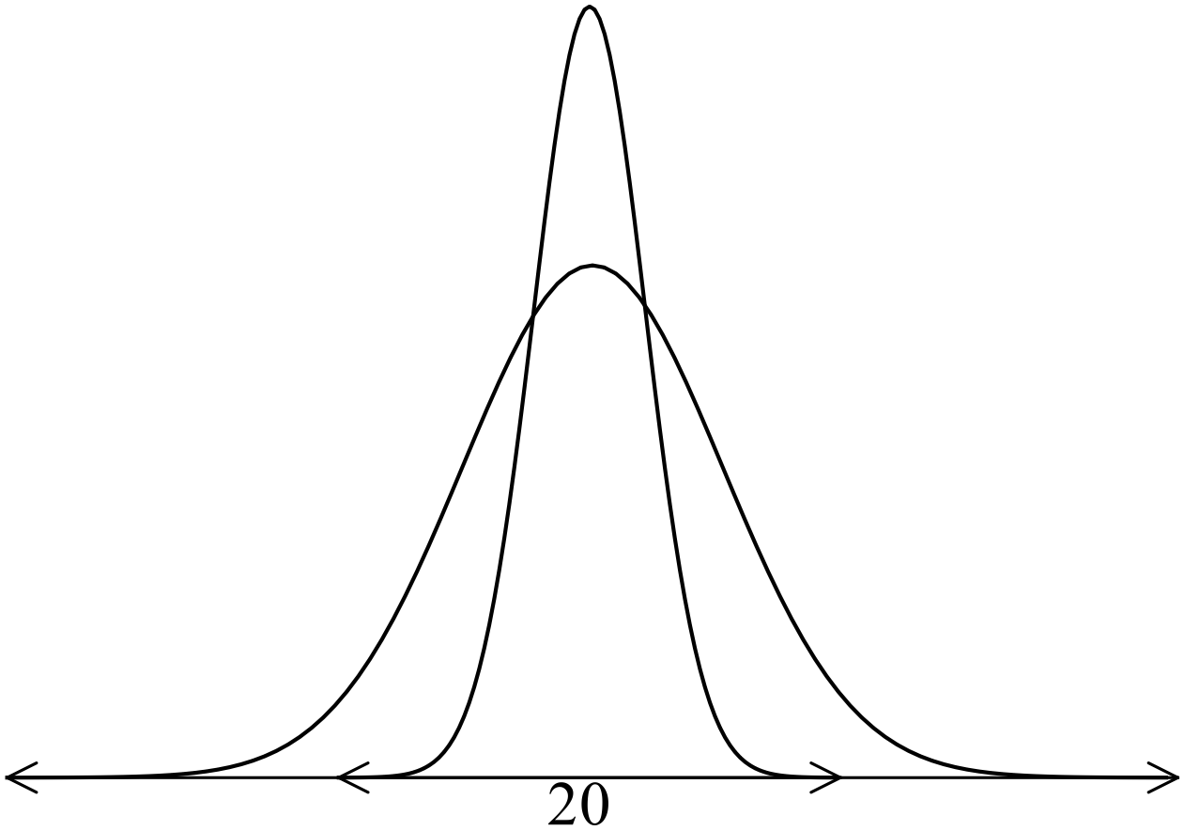 ✓✓✓

**Question 6 (6 marks)**

(a) “Income level” is ordinal aso income levels can be ranked. ✓✓

(b)

|  |  |
| --- | --- |
| Score | Frequency |
| 2 | 4 |
| 3 | 1 |
| 4 | 3 |
| 5 | 0 |
| 6 | 1 |
| 7 | 2 |
| 8 | 3 |

✓

✓

(c) The data is tightly clustered and skewed to the right. ✓

The mean of the distribution is higher than the median as it is pulled higher by the

extreme scores to the right. ✓

**END OF SECTION ONE**

**SECTION 2 – Calculator-assumed**

**Question 7 (6 marks)**

(a)  ✓✓

(b) (i)  ✓✓✓ -1/error

(ii)  ✓

There were 75 people served.

**Question 8 (11 marks)**



(a)  ✓

 ✓

The 420 gram for $195 is the cheaper. ✓

(b) (i)  ✓✓

(ii)  ✓✓

✓

✓

✓

(c) Profit 



✓

**Question 9 (3 marks)**



✓

✓

✓

**Question 10 (20 marks)**

(a)

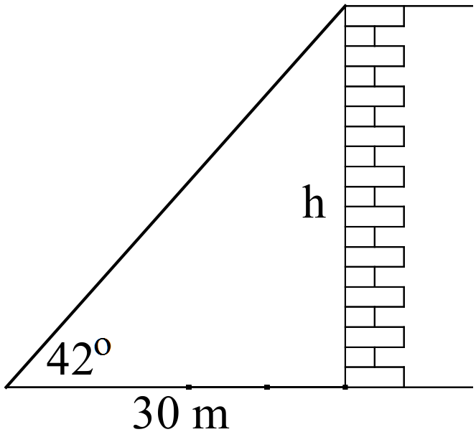



✓

✓

(b) (i)

✓

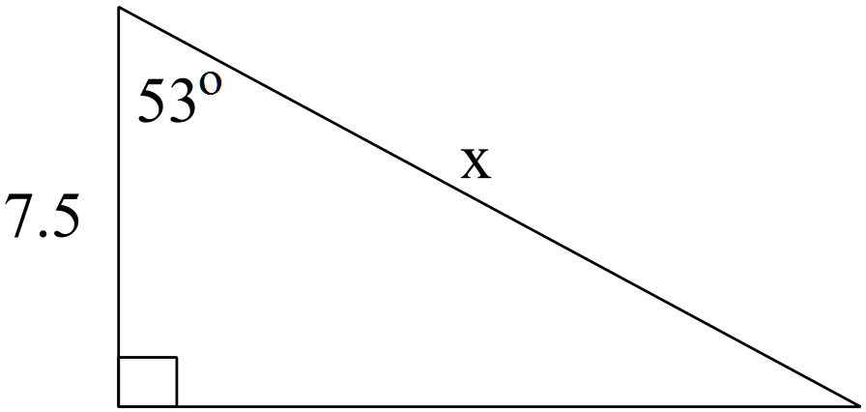

✓

 (ii)

✓

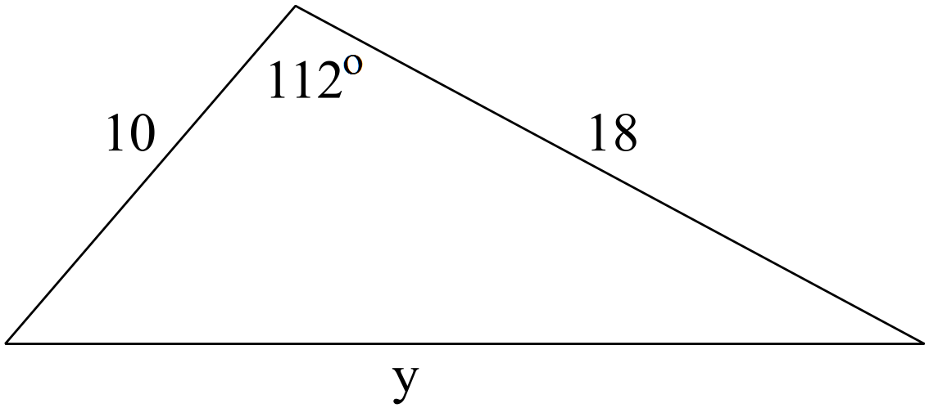

✓

 (iii)

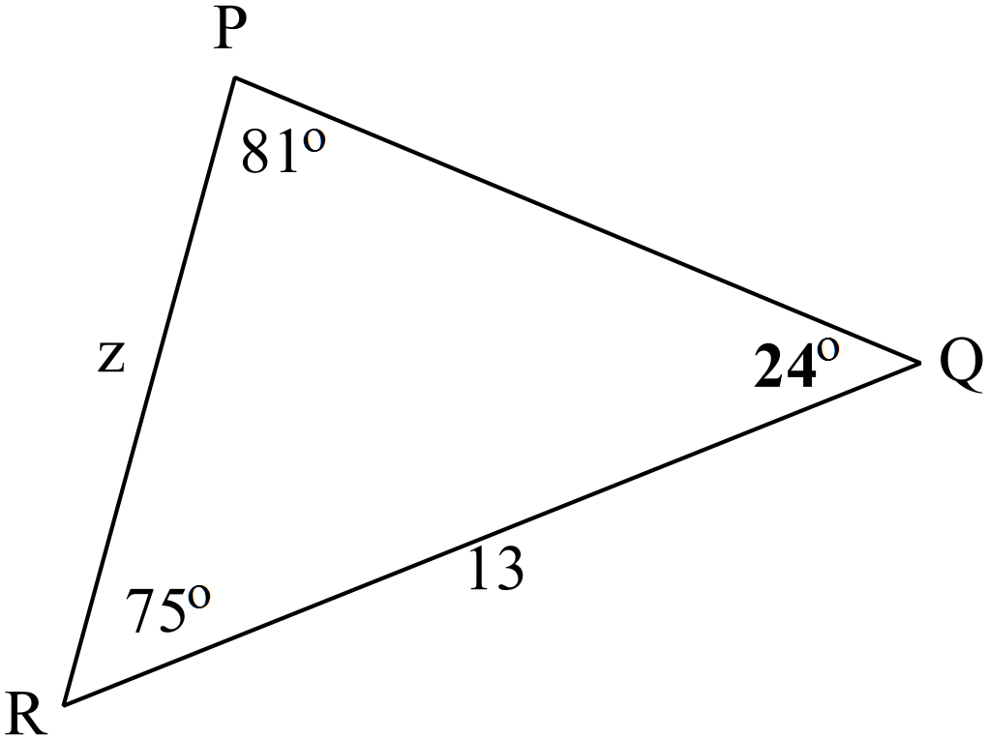

✓

✓

(c)

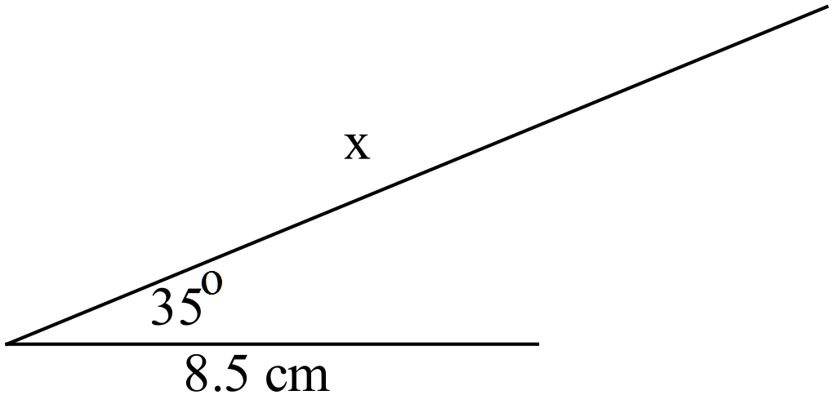

(i)



✓

✓

(ii)

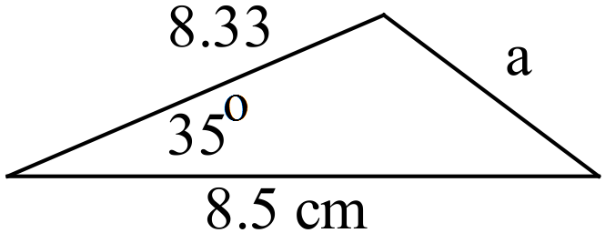



✓

✓

(d) (i)

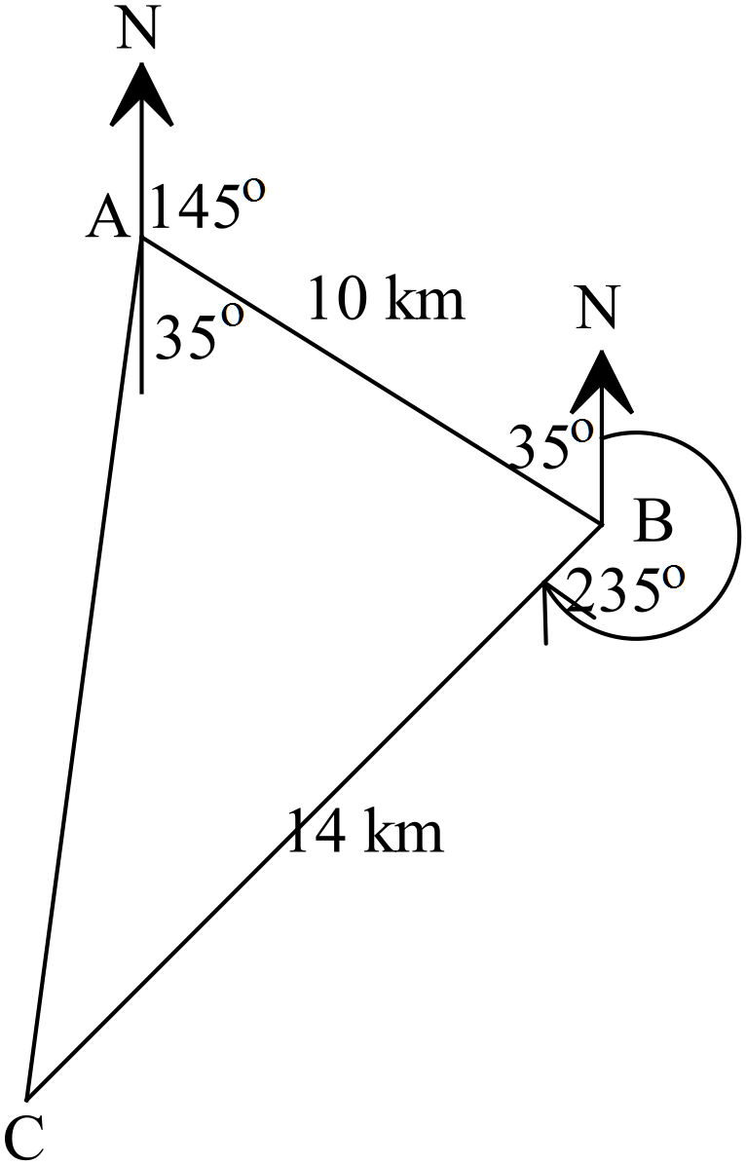

✓

✓

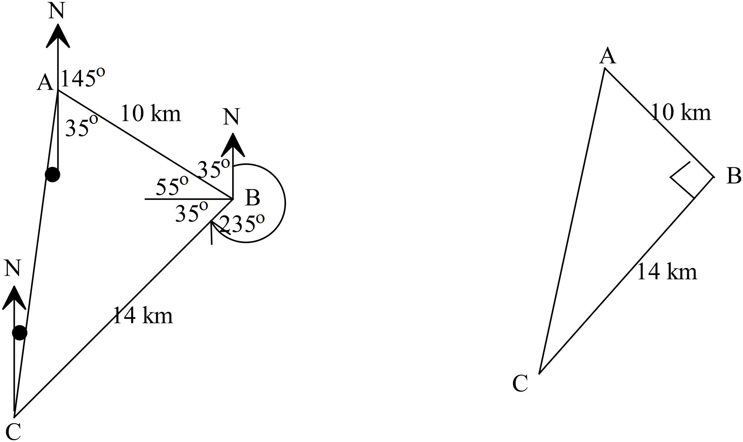 (ii)

✓



✓

✓

✓

The direction to the starting point is 019.5o

(iii)  ✓✓

**Question 11 (9 marks)**

(a) 



✓

✓

✓

(b)

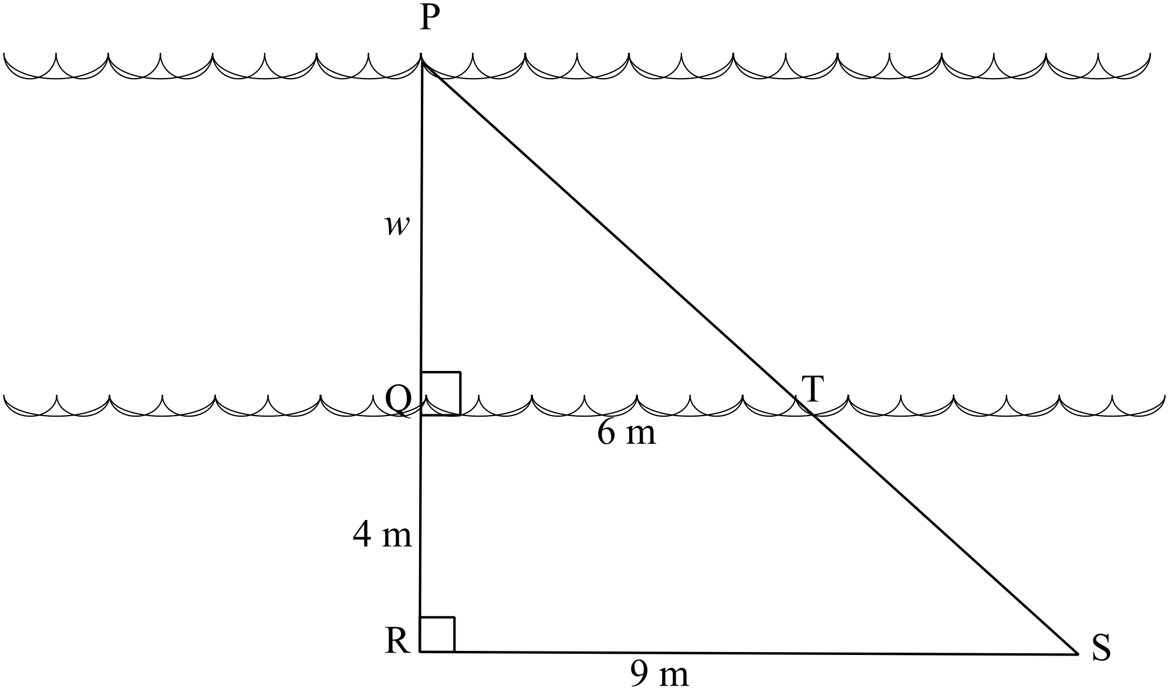

(i) In triangles PQT and PRS,

✓



✓

(ii) 

✓✓



✓

✓

The river is 8 metres wide.

**Question 12 (9 marks)**

(a)

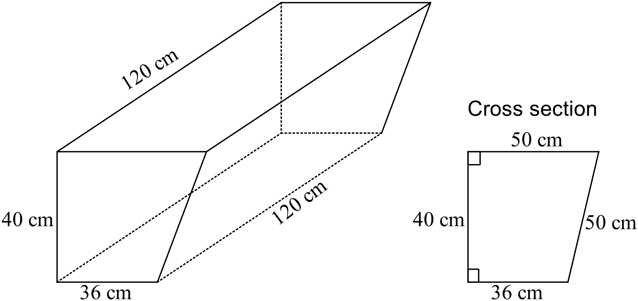

✓

Area of the end 

✓

Volume 

✓

(b)

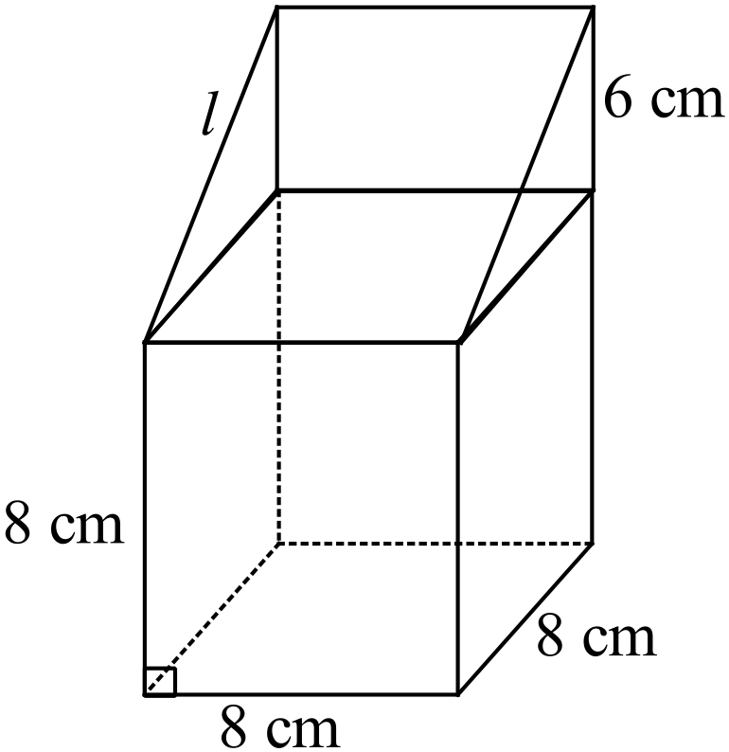

(i) 

✓



✓✓

✓

(ii) 

✓✓

(iii) Enlarged volume = 

✓✓

**Question 13 (18 marks)**

(a) (i)  ✓✓

(ii)  ✓✓

(iii)  ✓✓

(iv) *P*(the lightest weight of the heaviest 70 % of the breed) = 6.32 kg ✓✓✓

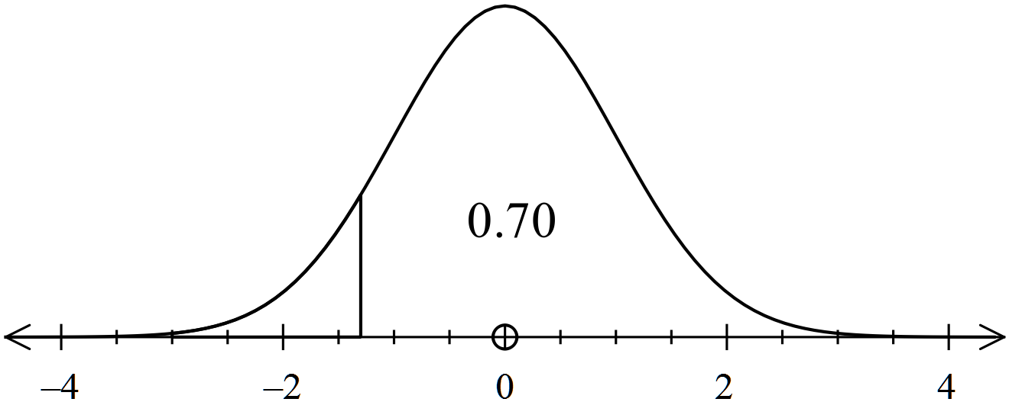

(b) Weight 0 sd ✓

Height 1.95 sd above the mean ✓

Chess 1.95 sd above the mean ✓

Football 2.7 sd below the mean ✓✓

(c) 

✓✓ ✓✓

**Question 14 (11 marks)**

(a) (i) 3,3,3 ✓✓

(ii) 9,10,11 ✓✓ answers may vary

(iii) 

✓ ✓

(b)

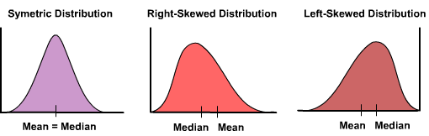

✓✓

✓✓

Mean of 10

Median of 12

Median of 8

Mean of 10

The two sets of data have identical distributions, but one is a reflection of the other.

Both are skewed with the mean away from the median (and distorted by the extreme

scores). ✓

**Question 15 (9 marks)**

(a)

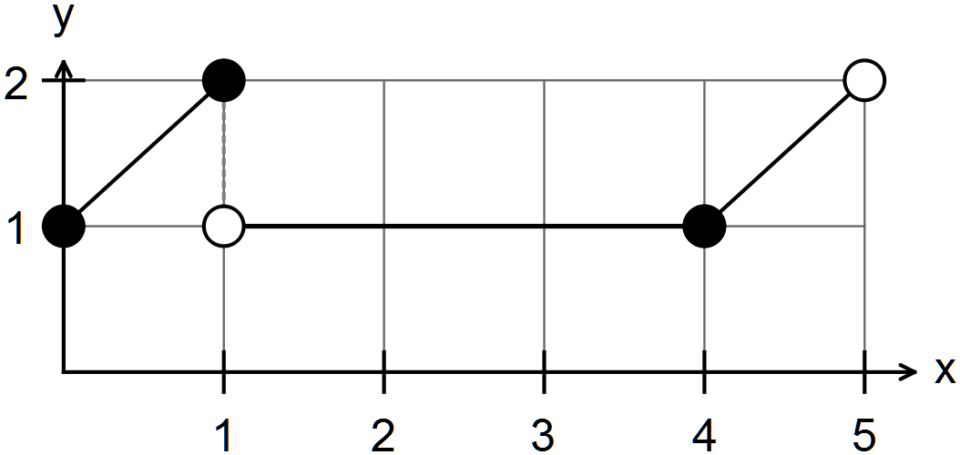

✓

✓✓

✓✓

(b) Let x = price of CD players

Let y = price of electric toothbrushes

✓



✓

✓

✓

Therefore CD players cost $130 and electric toothbrushes cost $70.

**End of solutions**